Architecture Document
- Application
  - In this architecture, all modules operate within the same application environment. Although the system is deployed as one application, it is internally divided into logical components such as the ingestion module, data quality computation engine, monitoring dashboard API, and alerting module. These components interact through internal function calls rather than network communication.
  - The application processes survey data in batches. When a batch of survey responses is uploaded by an administrator, the backend validates the data, removes duplicates, computes data quality metrics, and stores the results in the database. These metrics are then displayed in the monitoring dashboard for analysis.
  - The monolithic architecture was chosen because it simplifies development and deployment for the current scale of the project. Since all modules are integrated into a single system, data processing and monitoring tasks can be executed efficiently without the complexity of distributed service communication.
  - The architecture contains the following major modules:
    - Survey Ingestion Module
Handles survey batch uploads from administrators and validates the input data before processing.
    - Data Quality Engine
Computes quality metrics such as completeness, duplicate records, and outlier values after each batch ingestion.
    - Monitoring Dashboard Module
Provides graphical views and tables that allow administrators to monitor batch-level metrics and investigate specific data issues.
    - Alerting Module
Checks whether computed metrics exceed configured thresholds and triggers notifications when data quality issues are detected.
    - Configuration Module
Stores threshold values and notification settings used by the alerting system.
  - This architecture ensures that survey ingestion, data quality evaluation, metric storage, and monitoring are tightly integrated, allowing the system to provide immediate feedback on the quality of incoming data.
- Database
  - ER Diagram
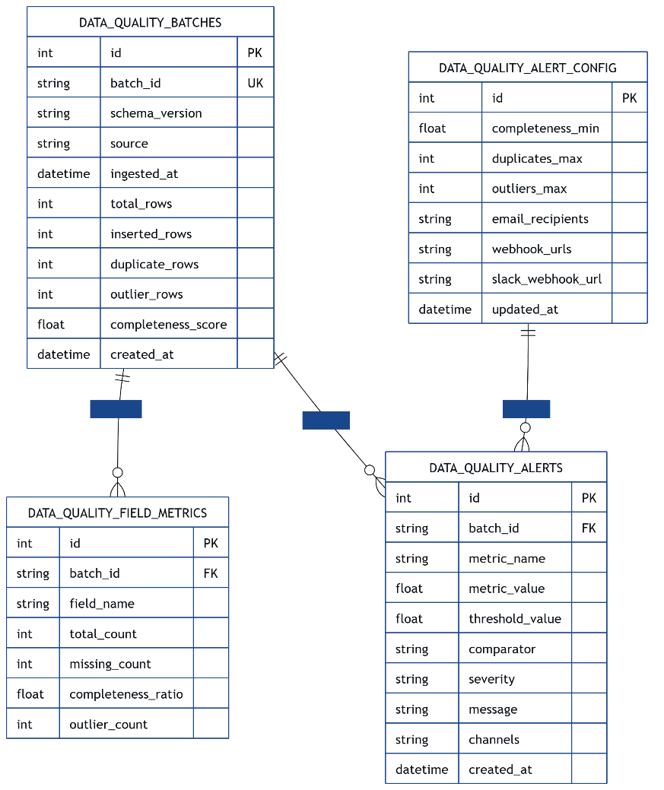
  - Schema Design
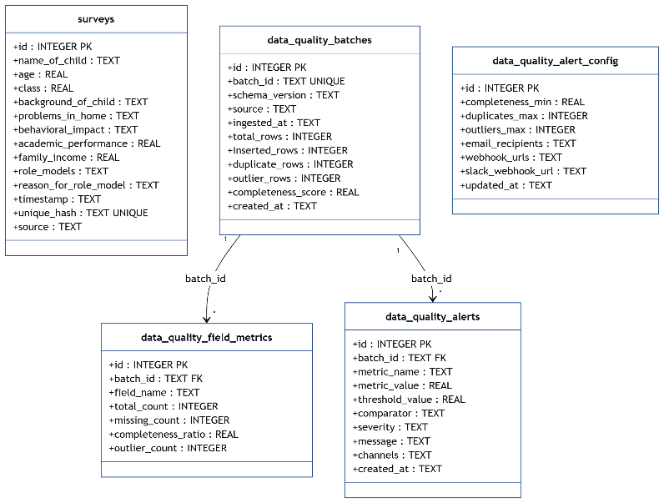
- Data Exchange Contract
  - Frequency of data exchanges
    - Different system components exchange data at different times:
    - Survey batch ingestion
Occurs whenever an administrator uploads a new dataset.
    - Metric computation
Executed immediately after data ingestion to evaluate data quality.
    - Dashboard monitoring requests
Triggered whenever a user opens or refreshes the monitoring dashboard.
    - Batch drill-down requests
Executed when a user selects a specific batch to inspect detailed metrics.
    - Alert dispatch
Occurs only when computed metrics exceed configured thresholds.
    - Configuration updates
Performed occasionally when administrators modify monitoring settings.
  - Data Sets
    - Survey Batch Data
Raw survey records uploaded by administrators.
    - Batch Quality Metrics
Summary statistics describing overall batch data quality.
    - Field Quality Metrics
Detailed metrics for each field in a batch.
    - Alert Configuration Data
Threshold values and notification settings.
    - Alert Event Data
Information about threshold violations.
    - Dashboard Monitoring Data
Aggregated metrics used for visualization.
    - Batch Drill-Down Data
Detailed metrics and alert history for a selected batch.

  - Mode of Exchanges (API, File, Queue etc.,)
    - The system uses several data exchange mechanisms:
    - REST APIs (JSON)
Used for communication between frontend and backend components.
    - Database Transactions (SQL)
Used to store survey data, quality metrics, and alerts.
    - Webhook Calls (HTTPS POST)
Used to send notifications to external systems such as Slack or monitoring services.

